**Hosting Tomcat Website in a Docker Container Manually**

* First we need an instance.
* Allow All TCP and MySQL in the security group.
* Install docker using command “yum install docker -y”.
* Now we will first create a database.
* For database we need MySQL in a container.
* We will use a MySQL image to create a container.
* Hit command “**docker run -d -p 3306:3306 -e MYSQL_ROOT_PASSWORD=”1234 mysql**” to pull and run the mysql image.
* The container will be created after running the image.
* Hit command “**docker ps**” to view all the running containers.
* Hit command “**docker exec -it container_name /bin/bash**” to enter in the container.

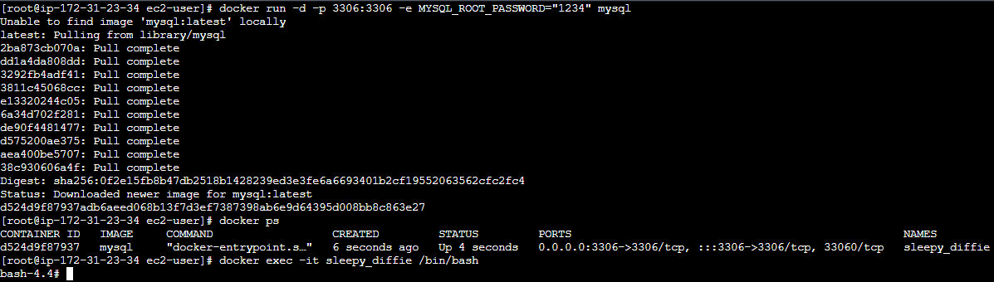

* Now we need to access the database.
* Hit command “**mysql -u root -p1234**”

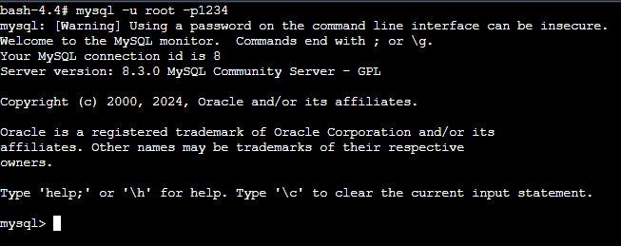

* Now we need to create a database for our application.
* Hit command “**create database studentapp**”.
* Hit command “**use studentapp**”.
* Now we need to create a table structure.
* Use the command below to create a table structure.
* **CREATE TABLE if not exists students(student_id INT NOT NULL AUTO_INCREMENT,**

**student_name VARCHAR(100) NOT NULL,**

**student_addr VARCHAR(100) NOT NULL,**

**student_age VARCHAR(3) NOT NULL,**

**student_qual VARCHAR(20) NOT NULL,**

**student_percent VARCHAR(10) NOT NULL,**

**student_year_passed VARCHAR(10) NOT NULL,**

**PRIMARY KEY (student_id)**

**);**

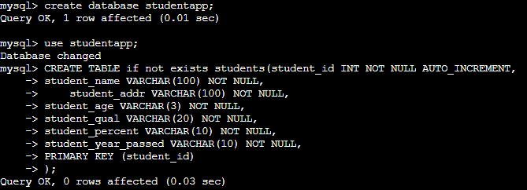

* Table created.
* Hit command “**desc students;**” to view the table structure.

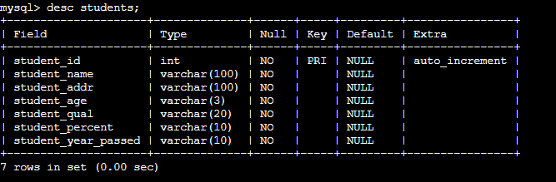

* Now the database is created.
* Exit from mysql and the container.
* Now we need the IP of the mysql container.
* Hit command “**docker inspect container_name**”.
* Copy the IP of the mysql container.
* Now we have to host the application in the tomcat.
* First we need **centos 7** image.
* Hit command “**docker run -it -p 8080:8080 centos:7**”.
* This command will pull the image if not present locally and run the image.
* Also we will enter the container.
* Now we have entered the container.
* Change the directory to /opt.

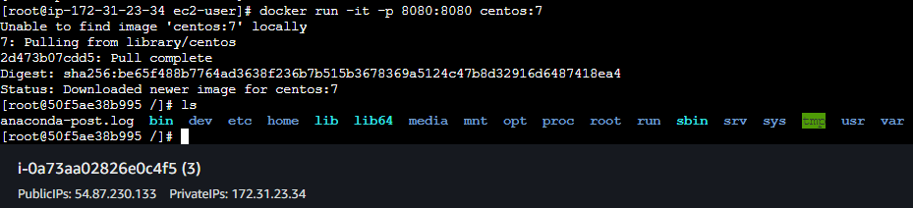

* Now we have to download the tomcat here.
* Hit command “**curl -O** [**https://dlcdn.apache.org/tomcat/tomcat-9/v9.0.87/bin/apache-tomcat-9.0.87.tar.gz**](https://dlcdn.apache.org/tomcat/tomcat-9/v9.0.87/bin/apache-tomcat-9.0.87.tar.gz)” to download tomcat.

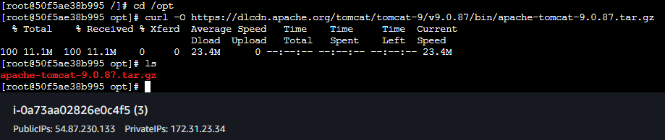

* Extract the file using command “tar -xvf apache-tomcat-9.0.87.tar.gz”.
* Now we need our application.
* Hit command “**curl -O** [**https://webapp2-akashapp.s3.amazonaws.com/student.war**](https://webapp2-akashapp.s3.amazonaws.com/student.war)” to download the studentapp war file.
* We also need a mysql connector.
* Hit command “**curl -O** [**https://webapp-akash.s3.amazonaws.com/mysql-connector-j-8.3.0.jar**](https://webapp-akash.s3.amazonaws.com/mysql-connector-j-8.3.0.jar)” to download the connector file.
* Now move the student.war file to webapps and mysql-connector to lib.

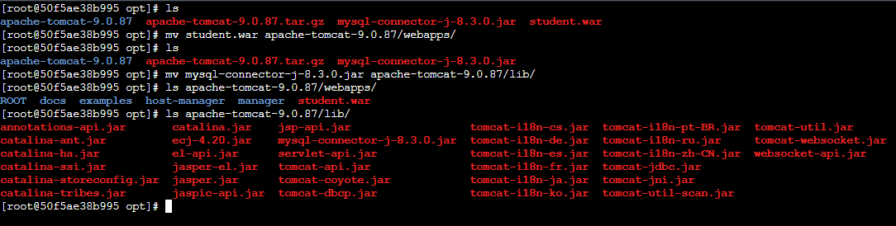

* Now we need a java environment for the tomcat service to run.
* Hit command “**yum install java -y**” to install java.
* Now we need to start the Catalina.sh
* Hit command **“./apache-tomcat-9.0.87/bin/catalina.sh start**” to start the service.

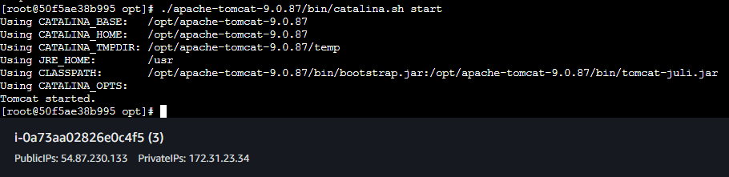

* Now hit the IP of your instance and check if the page is visible.
* Our registration page is visible.

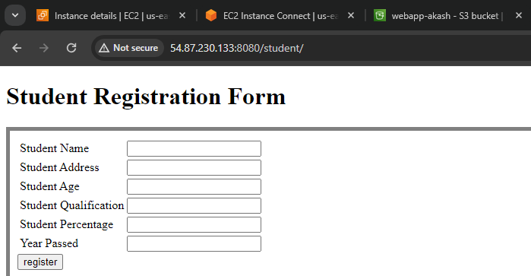

* Now we have to do the configuration so the data should be saved to database.
* Open the context.xml file in editor.
* The context.xml file is located in apache-tomcat/conf.
* Add the configuration to the context.xml file.
* Give the mysql containe IP address as the endpoint.

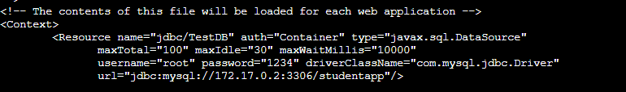

* Now we need to stop the Catalina.sh service.
* Hit command **“./apache-tomcat-9.0.87/bin/catalina.sh stop**” to stop the service.
* Hit command **“./apache-tomcat-9.0.87/bin/catalina.sh start**” to start the Catalina service.

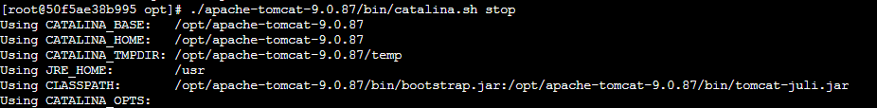

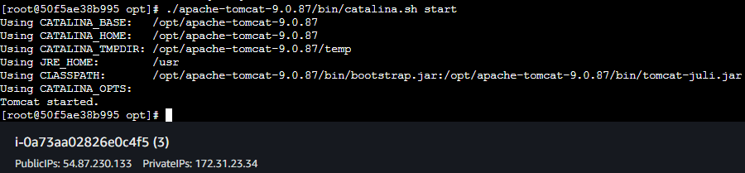

* Now hit the IP address.
* Fill the form and click register button.

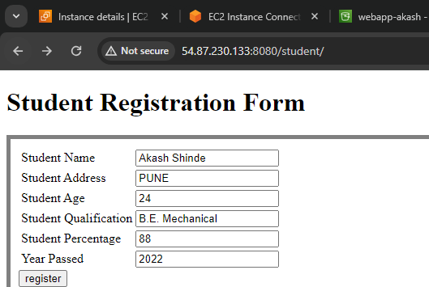

* Data saved successfully in the database.

